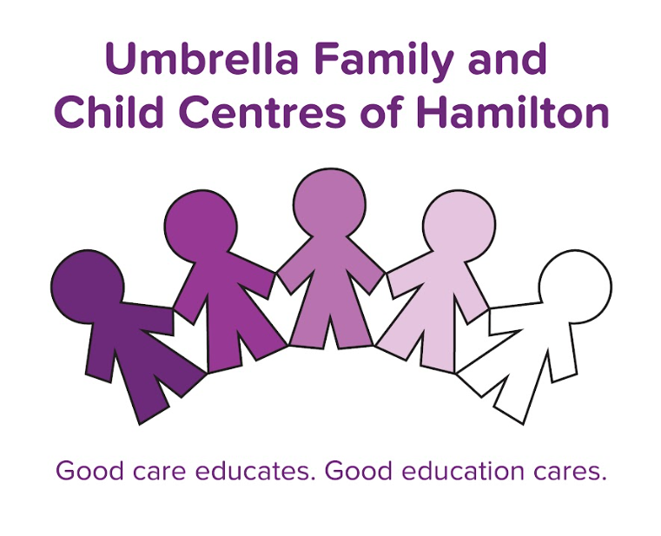

Centre Protocols- Discussion Points

These protocols were established to streamline expectations and processes pedagogically across the Umbrella. The goal is that every child, regardless of which Umbrella location they attend, receives a high-quality child care experience. Further, it helps staff, who may transition from site to site, either due to their role (Supply, Relief) or due to location changes, be successful in understanding streamlined expectations.
These were developed by the PE Team as a result of their many visits to our programs, along with significant input and consultation from the Quality Committee- comprised primarily of frontline staff.
The goal of these documents is to help everyone understand the expectations of our programs and to support staff in setting internals goals for continued quality improvement.
For many educators, the expectations outlined in this document are not new and are representative of the amazing care we are already providing.
In this field, there are so many ‘unwritten rules’ for best practice. This guide serves to support staff in learning these ‘unwritten rules’ and aid in the learning process.

